**WordPress Blog using Docker Compose**:

Prerequisite To launch WordPress site with database using docker-compose on Centos-7.

**Step 1**: Install docker

# yum install docker

**Step 2**: Install docker-compose

# sudo curl -L "https://github.com/docker/compose/releases/download/1.25.4/docker-compose-$(uname -s)-$(uname -m)" -o /usr/local/bin/docker-compose.

**Step 3**: To assign execute permission to docker-compose file.

# sudo chmod +x /usr/local/bin/docker-compose

**Step 4**: Now create “docker-compose.yml” file:

# vim docker-compose.yml

**Step 5**: Now put following code in your “docker-compose.yml” file

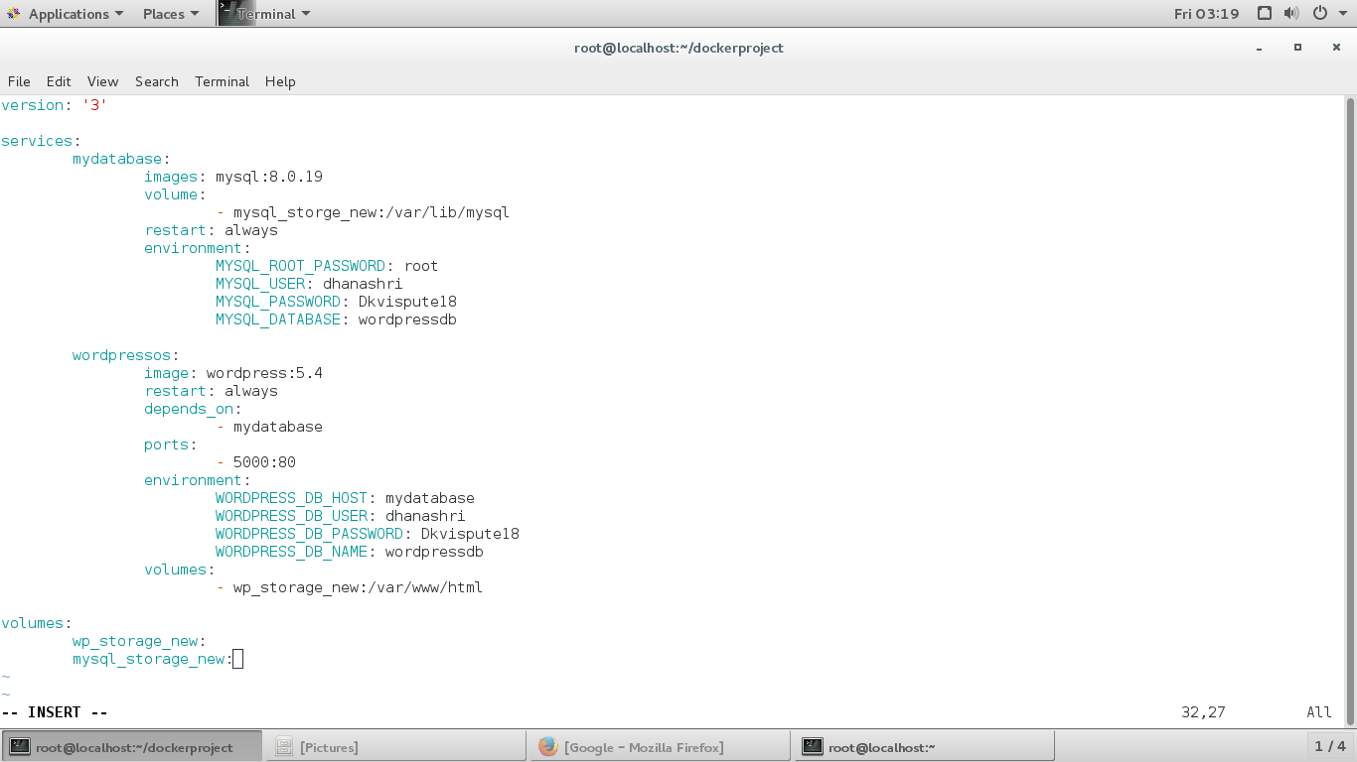

**Step 6**: Now to run yml file use:

# docker-compose up -d

Now your both containers are up with above mentioned configuration.

Go to browser type localhost:5000

